Pre Ap Computer Science I Jeroo Lab 5B – Finding Betty Lab Value - 100

Lab Goal: To analyze a problem and involve basic decision making in creating a solution for the problem. You must determine how to use compound conditionals in order for Barney to move through the maze. You must create methods involving complex conditionals so that your Jeroo can continue to move. Pay close attention – it will only require a few basic decisions if you take a careful look at the decisions that need to be made. Do not assume that because you can do something….that you must do it.
Lab Description: This lab requires you to use the compound commands AND ( && ), and NOT( ! ) in order to create the method needed. Your Jeroo must make its way through the entire maze and stop facing the water. You can solve this with just a few methods…or maybe 1 method if you are careful. Think in simplest terms. It is not as difficult as it first appears. Methods will definitely be used more than once.

Starting Screen:
Files Needed:
Jeroo_Lab5B.jsc
FindingBety.jev

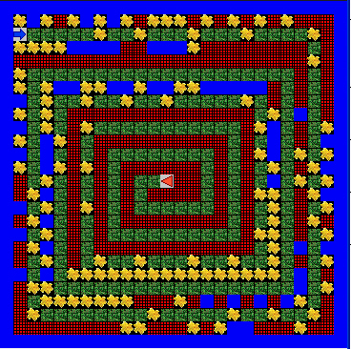
algorithm help

Preconditions
- What makes me stop?
- Which way do I turn?
- When do I stop?
- Why do I move?

Postcondition
- Successful hop through the maze.
- Jeroo is not in the water.
- Jeroo is not caught in a net
- Jeroo is facing East.
- Barney is facing Betty.

Ending Screen:
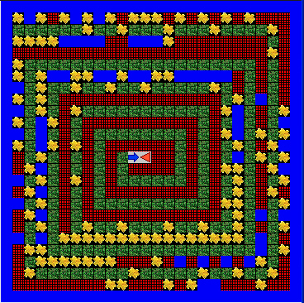
BONUSES

Without creating any other methods, can you Barney back where he started?
+10

Bonus 2
Without creating any more methods,
have Betty follow Barney’s trail and stop
behind him. Once she stops, Barney
should turn to face her. +15

